Chapter 5

Securing wireless networks

Now since we have seen the vulnerabilities in wireless networks, let us now take a look at how to secure the wireless networks. There different methods to solve this problem, either by doing it manually by yourself or using some tools to do it.

5.1 Manually defending wireless attacks
To do it manually a basic knowledge of network and networking devices is necessary.
- Change the default SSID after WLAN configuration.
- Do not set a simple password, use a combination of alphabets, numbers and symbols.
- Enable MAC filtering on access point or router. That is adding the MAC address of the permitted devices to the access point.
- Stop broadcasting the SSID.
- By default, certain messages broadcast the ID to everyone stop this by using SSID cloaking.
- Check the wireless devices for configuration or setup problems regularly.
- Frequently check for updates on all the wireless equipment and keep them updated.
- Place the wireless equipment of the access point in a properly secured place.
- Implement WPA2 Enterprise instead of wi-fi protected access (WEP).
- Using a centralised server for authentication is best preferred in corporate sectors.
- Use a firewall or packet filter in between the AP and the corporate intranet.

5.2 Defending wireless attacks using tools
Wireless networks can be secured not only with manual methods but also with wireless security tools. These tools can be helpful in securing the WLAN more secure when combined with the manual methods. In a sense, tools are just automation for few things that can be done manually.

Rogue Scanner
It is an opens source networks security tool for automatically discovering rogue wireless access point that might provide to access your data. It can also be used for network asset discovery. The Figure 5-1 below shows the rogue scanner displaying all the network connected devices such as printers, routers and computer.

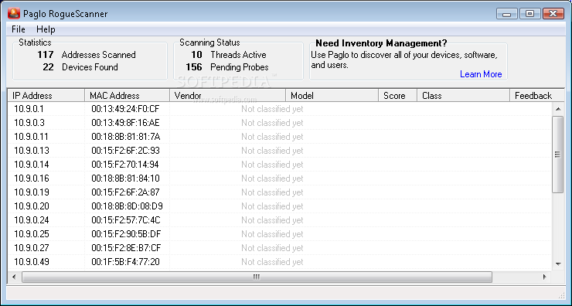
Figure 5-1 RogueScanner discovers rogue wireless access points.

AirDefence
AirDefence shown in the Figure 5-2 is an 802.1/a/b/g, a UI-based platform for wireless monitoring, wireless LAN intrusion detection and security solution that recognizes security risks and attack. It observes the condition of the wireless LAN and offers a real-time stats.
Its features include the following:
• It detects all rogue WLANs.
• It secures a wireless LAN by recognizing and responding to intruders and attacks as they occur.
• It carries out real-time network audits to record all hardware, track all wireless LAN activity, and enforce WLAN policies for security and management.
• It observes the health of the network, identifying and responding to hardware failures, network interferences, and performance degradation.
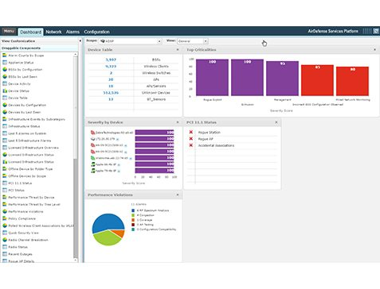
Figure 5-2 AirDefence tool screenshot.

CommView for WiFi PPC
CommView for WiFi PPC is a special, lightweight edition of CommView for WiFi that runs on Pocket PC handheld computers. It is designed for express wireless site surveys, as well as capturing and analyzing network packets on wireless 802.11b/g networks. With CommView for WiFi PPC, shown in Figure 5-3, the user can do the following:
• Scan the air for Wi-Fi signals
• Select channels for monitoring
• Detect access points and wireless stations
• Capture packets
• Measure signal strength
• View the list of network connections
• Examine and filter individual packets
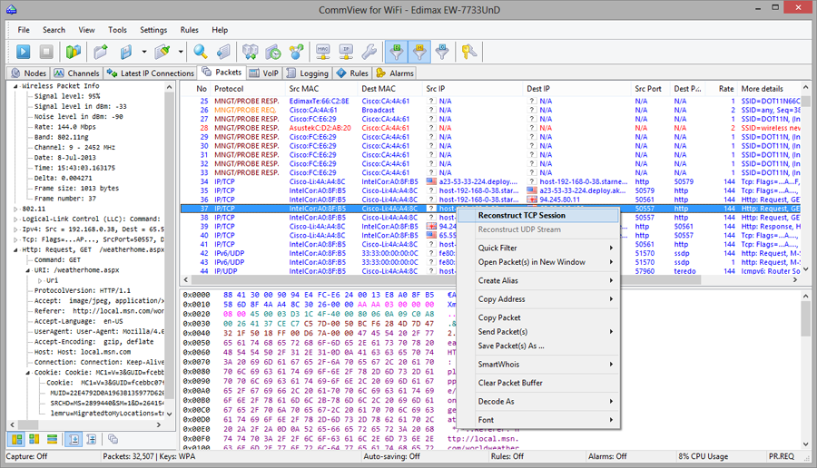
Figure 5-3 commView analyses network data.

Airmagnet analyser
AirMagnet analyser shown in Figure 5-4 is a standard tool for automatically detecting vulnerabilities that are often overlooked, perform a live interactive network test to pinpoint network problems, track down rogues and block them either wirelessly or at the wired port.
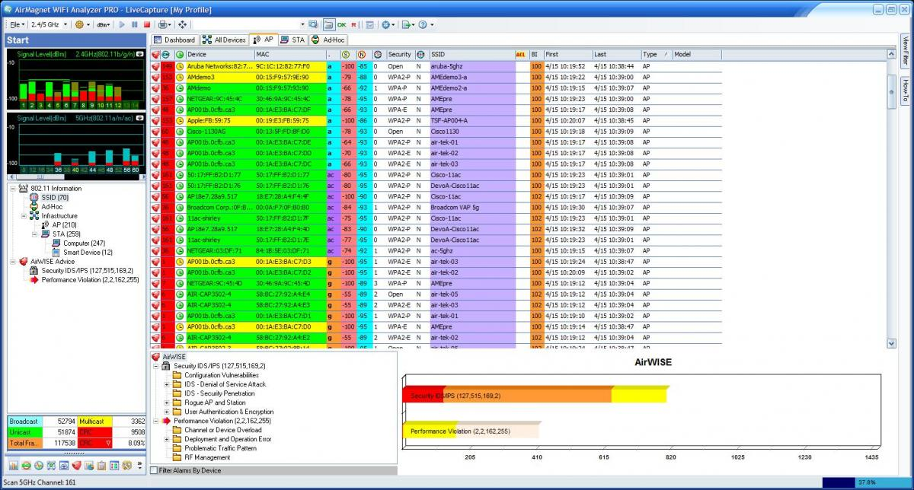
Figure 5-4 AirMagnet wifi analyser screenshot
There are other tools that can help, but these are some of the best and enough for protecting a wireless network.

